**Fragment :**

In Android, [Fragment](https://abhiandroid.com/ui/fragment/) is a part of an activity which enable more modular activity design. It will not be wrong if we say a [fragment](https://abhiandroid.com/ui/fragment/) is a kind of sub-activity. It represents a behaviour or a portion of user interface in an Activity. We can combine multiple Fragments in Single Activity to build a multi panel UI and reuse a [Fragment](https://abhiandroid.com/ui/fragment/) in multiple Activities. We always need to embed Fragment in an activity and the fragment lifecycle is directly affected by the host activity’s lifecycle.

Important Related Read: [Fragment Lifecycle](https://abhiandroid.com/ui/fragment-lifecycle-example-android-studio.html)

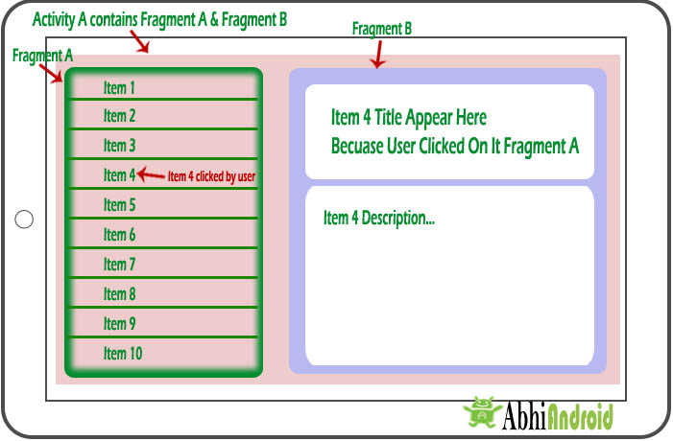

We can create Fragments by extending Fragment class or by inserting a Fragment into our Activity layout by declaring the Fragment in the activity’s layout file, as a <fragment> element. We can manipulate each Fragment independently, such as add or remove them.

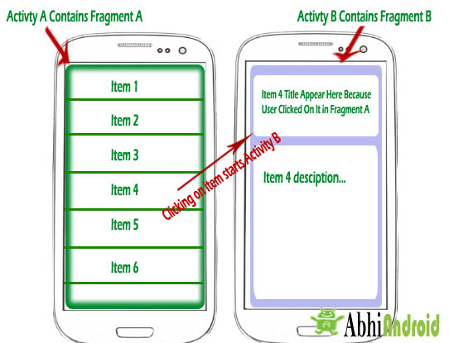

While performing Fragment Transaction we can add a Fragment into back stack that’s managed by the Activity. back stack allow us to reverse a Fragment transaction on pressing Back [button](https://abhiandroid.com/ui/button/) of device. For Example if we replace a Fragment and add it in back stack then on pressing the Back [button](https://abhiandroid.com/ui/button/) on device it display the previous Fragment.

**Need Of Fragments In Android:**

Before the introduction of Fragment’s we can only show a single Activity on the screen at one given point of time so we were not able to divide the screen and control different parts separately. With the help of Fragment’s we can divide the screens in different parts and controls different parts separately.

By using Fragments we can comprise multiple Fragments in a single Activity. Fragments have their own events, layouts and complete life cycle. It provide flexibility and also removed the limitation of single Activity on the screen at a time.

**Basic Fragment Code In XML:**

<fragment

android:id="@+id/fragments"

android:layout_width="match_parent"

android:layout_height="match_parent" />

**Create A Fragment Class In Android Studio:**

For creating a Fragment firstly we extend the Fragment class, then override key lifecycle methods to insert our app logic, similar to the way we would with an Activity class. While creating a Fragment we must use onCreateView() callback to define the layout and in order to run a Fragment.

import android.os.Bundle;

import android.support.v4.app.Fragment;

import android.view.LayoutInflater;

import android.view.ViewGroup;

public class FirstFragment extends Fragment {

@Override

public View onCreateView(LayoutInflater inflater, ViewGroup container,

Bundle savedInstanceState) {

// Inflate the layout for this fragment

return inflater.inflate(R.layout.fragment_first, container, false);

}

}

Here the inflater parameter is a LayoutInflater used to inflate the layout, container parameter  is the parent ViewGroup (from the activity’s layout) in which our Fragment layout will be inserted.

The savedInstanceState parameter is a Bundle that provides data about the previous instance of the Fragment. The inflate() method has three arguments first one is the resource layout which we want to inflate, second is the ViewGroup to be the parent of the inflated layout. Passing the container is important in order for the system to apply layout parameters to the root view of the inflated layout, specified by the parent view in which it’s going and the third parameter is a boolean value indicating whether the inflated layout should be attached to the ViewGroup (the second parameter) during inflation.

**Following are important points about fragment −**

* A fragment has its own layout and its own behaviour with its own life cycle callbacks.
* You can add or remove fragments in an activity while the activity is running.
* You can combine multiple fragments in a single activity to build a multi-pane UI.
* A fragment can be used in multiple activities.
* Fragment life cycle is closely related to the life cycle of its host activity which means when the activity is paused, all the fragments available in the activity will also be stopped.
* A fragment can implement a behaviour that has no user interface component.
* Fragments were added to the Android API in Honeycomb version of Android which API version 11.

You create fragments by extending **Fragment** class and You can insert a fragment into your activity layout by declaring the fragment in the activity's layout file, as a **<fragment>** element.

Prior to fragment introduction, we had a limitation because we can show only a single activity on the screen at one given point in time. So we were not able to divide device screen and control different parts separately. But with the introduction of fragment we got more flexibility and removed the limitation of having a single activity on the screen at a time. Now we can have a single activity but each activity can comprise of multiple fragments which will have their own layout, events and complete life cycle.

Following is a typical example of how two UI modules defined by fragments can be combined into one activity for a tablet design, but separated for a handset design.

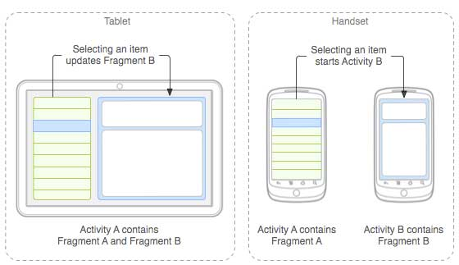

The application can embed two fragments in Activity A, when running on a tablet-sized device. However, on a handset-sized screen, there's not enough room for both fragments, so Activity A includes only the fragment for the list of articles, and when the user selects an article, it starts Activity B, which includes the second fragment to read the article.

Fragment Life Cycle

Android fragments have their own life cycle very similar to an android activity. This section briefs different stages of its life cycle.

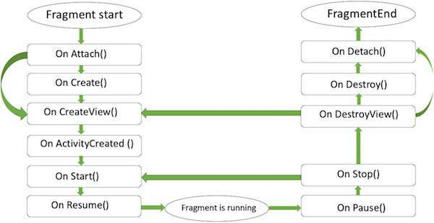

Fragment lifecycle

Here is the list of methods which you can to override in your fragment class −

* **onAttach()**The fragment instance is associated with an activity instance.The fragment and the activity is not fully initialized. Typically you get in this method a reference to the activity which uses the fragment for further initialization work.
* **onCreate()** The system calls this method when creating the fragment. You should initialize essential components of the fragment that you want to retain when the fragment is paused or stopped, then resumed.
* **onCreateView()** The system calls this callback when it's time for the fragment to draw its user interface for the first time. To draw a UI for your fragment, you must return a **View** component from this method that is the root of your fragment's layout. You can return null if the fragment does not provide a UI.
* **onActivityCreated()**The onActivityCreated() is called after the onCreateView() method when the host activity is created. Activity and fragment instance have been created as well as the view hierarchy of the activity. At this point, view can be accessed with the findViewById() method. example. In this method you can instantiate objects which require a Context object
* **onStart()**The onStart() method is called once the fragment gets visible.
* **onResume()**Fragment becomes active.
* **onPause()** The system calls this method as the first indication that the user is leaving the fragment. This is usually where you should commit any changes that should be persisted beyond the current user session.
* **onStop()**Fragment going to be stopped by calling onStop()
* **onDestroyView()**Fragment view will destroy after call this method
* **onDestroy()**onDestroy() called to do final clean up of the fragment's state but Not guaranteed to be called by the Android platform.

**Tablet :**

  Tablets offer great style, power, portability and can be put to a range of good uses, both around the home and out and about. But while they may come cheap (cheaper than a laptop, anyway!) a tablet is still an expense worth thinking about before taking the plunge.

**They're so light and portable.**

Whether you like getting work done or getting entertained on the go, tablets offer one clear advantage: they're portable. Tablets are often about one third the weight of a standard laptop, so the physical strain of carrying a lightweight tablet is far less.

Meanwhile, the typical screen size on a tablet is around 7-10 inches, which means they easily fit into most backpacks, carry bags, or briefcases.

This makes tablets a great asset for students, travelers, commuters and professionals who have to travel a lot on business.

**2. You can get connectivity anywhere.**

If you have things to do online and your phone can't handle it, the great thing about a tablet is it can get the internet anywhere. That is, as long as you get a [**4G tablet**](https://www.whistleout.com.au/Tablets/Guides/do-you-need-a-4g-ipad). No lugging your laptop around cafes and libraries hunting for free WiFi. Just power up and get online.

This makes tablets particularly handy for professionals. Whether you need to check emails, edit documents on the cloud or just stay up to date with the latest news in your industry, a tablet can help you get it done easily anywhere.

**3. A tablet is more affordable than a laptop.**

These days it seems like having a home computer is compulsory. But actually, if you're only using your computer for light web browsing, some email, Facebook and Netflix, a tablet might do just as well.

Tablet prices typically range from $100 to $1,000, whereas you're looking at between $400 and $3,000 for a laptop. So depending on what you want to use it for, a tablet could save you quite a bit of money, and offer more portability to boot.

**4. Tablets 'wake up' instantly.**

Most laptop computers generally take around 10-30 seconds to start up. However, the initial start up on a tablet is generally around 2-10 seconds. Once powered on, a tablet can "wake" from a sleep mode instantaneously. Nothing makes you feel like you're living on the cutting edge quite like a lightning-fast tech.

**5. They make excellent portable entertainment systems.**

Want an ebook for your long flight? Games on the bus? A bit of [**Netflix**](https://www.whistleout.com.au/PayTV/Guides/netflix-australia-everything-you-need-to-know) in bed? Sure, you can use a phone for all that but it's all so much better on a bigger screen. No matter where you go, with a tablet you'll never have an excuse for boredom.

**6. They're great for web browsing.**

Portability and fast start-up combine to make the tablet a first choice for quick web browsing, especially when you're away from your desk. A good example would be looking up a recipe for a meal. Set up the tablet in the kitchen, find a recipe online, and get cooking!

**7. They're handy for giving presentations.**

A rising trend in business is the use of tablets to run presentations. With presentation files on a tablet, it's relatively simple to share the content with a large screen in meeting rooms. And if you're travelling around to clients and giving presentations outside of the office, they're a lot easier to lug around than a laptop.

**Disadvantages of tablets pc:**

**1.** hardware is prone to damage.

**2.**weaker capabilities.

**3.** traditional keyboards are much more comfortable.

**4.** the screen size is too small in comparison with a laptop

**6.**do not come with optical drives for use with CDs or DVDs

**7.** ineffective for the cognition of complex engineering concepts.

**8.** potential screen damages and repair costs (more chances of screen damage to tablet PCs than to laptops; tablet computers are prone to problems like cracks, dead pixels, blown back-light bulbs and bad sensors).

**9.** difficulties to work on the small screen as compared to larger screen size of the laptops.

**10.** less number of ports.